**Curriculum Vitae/ Profile**

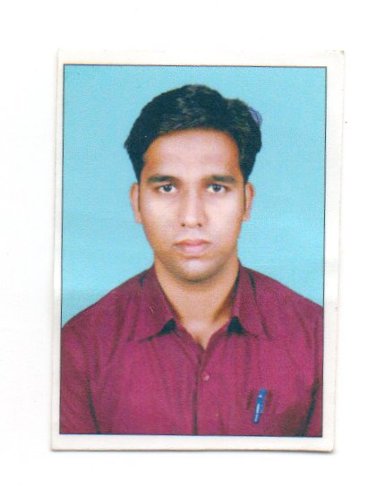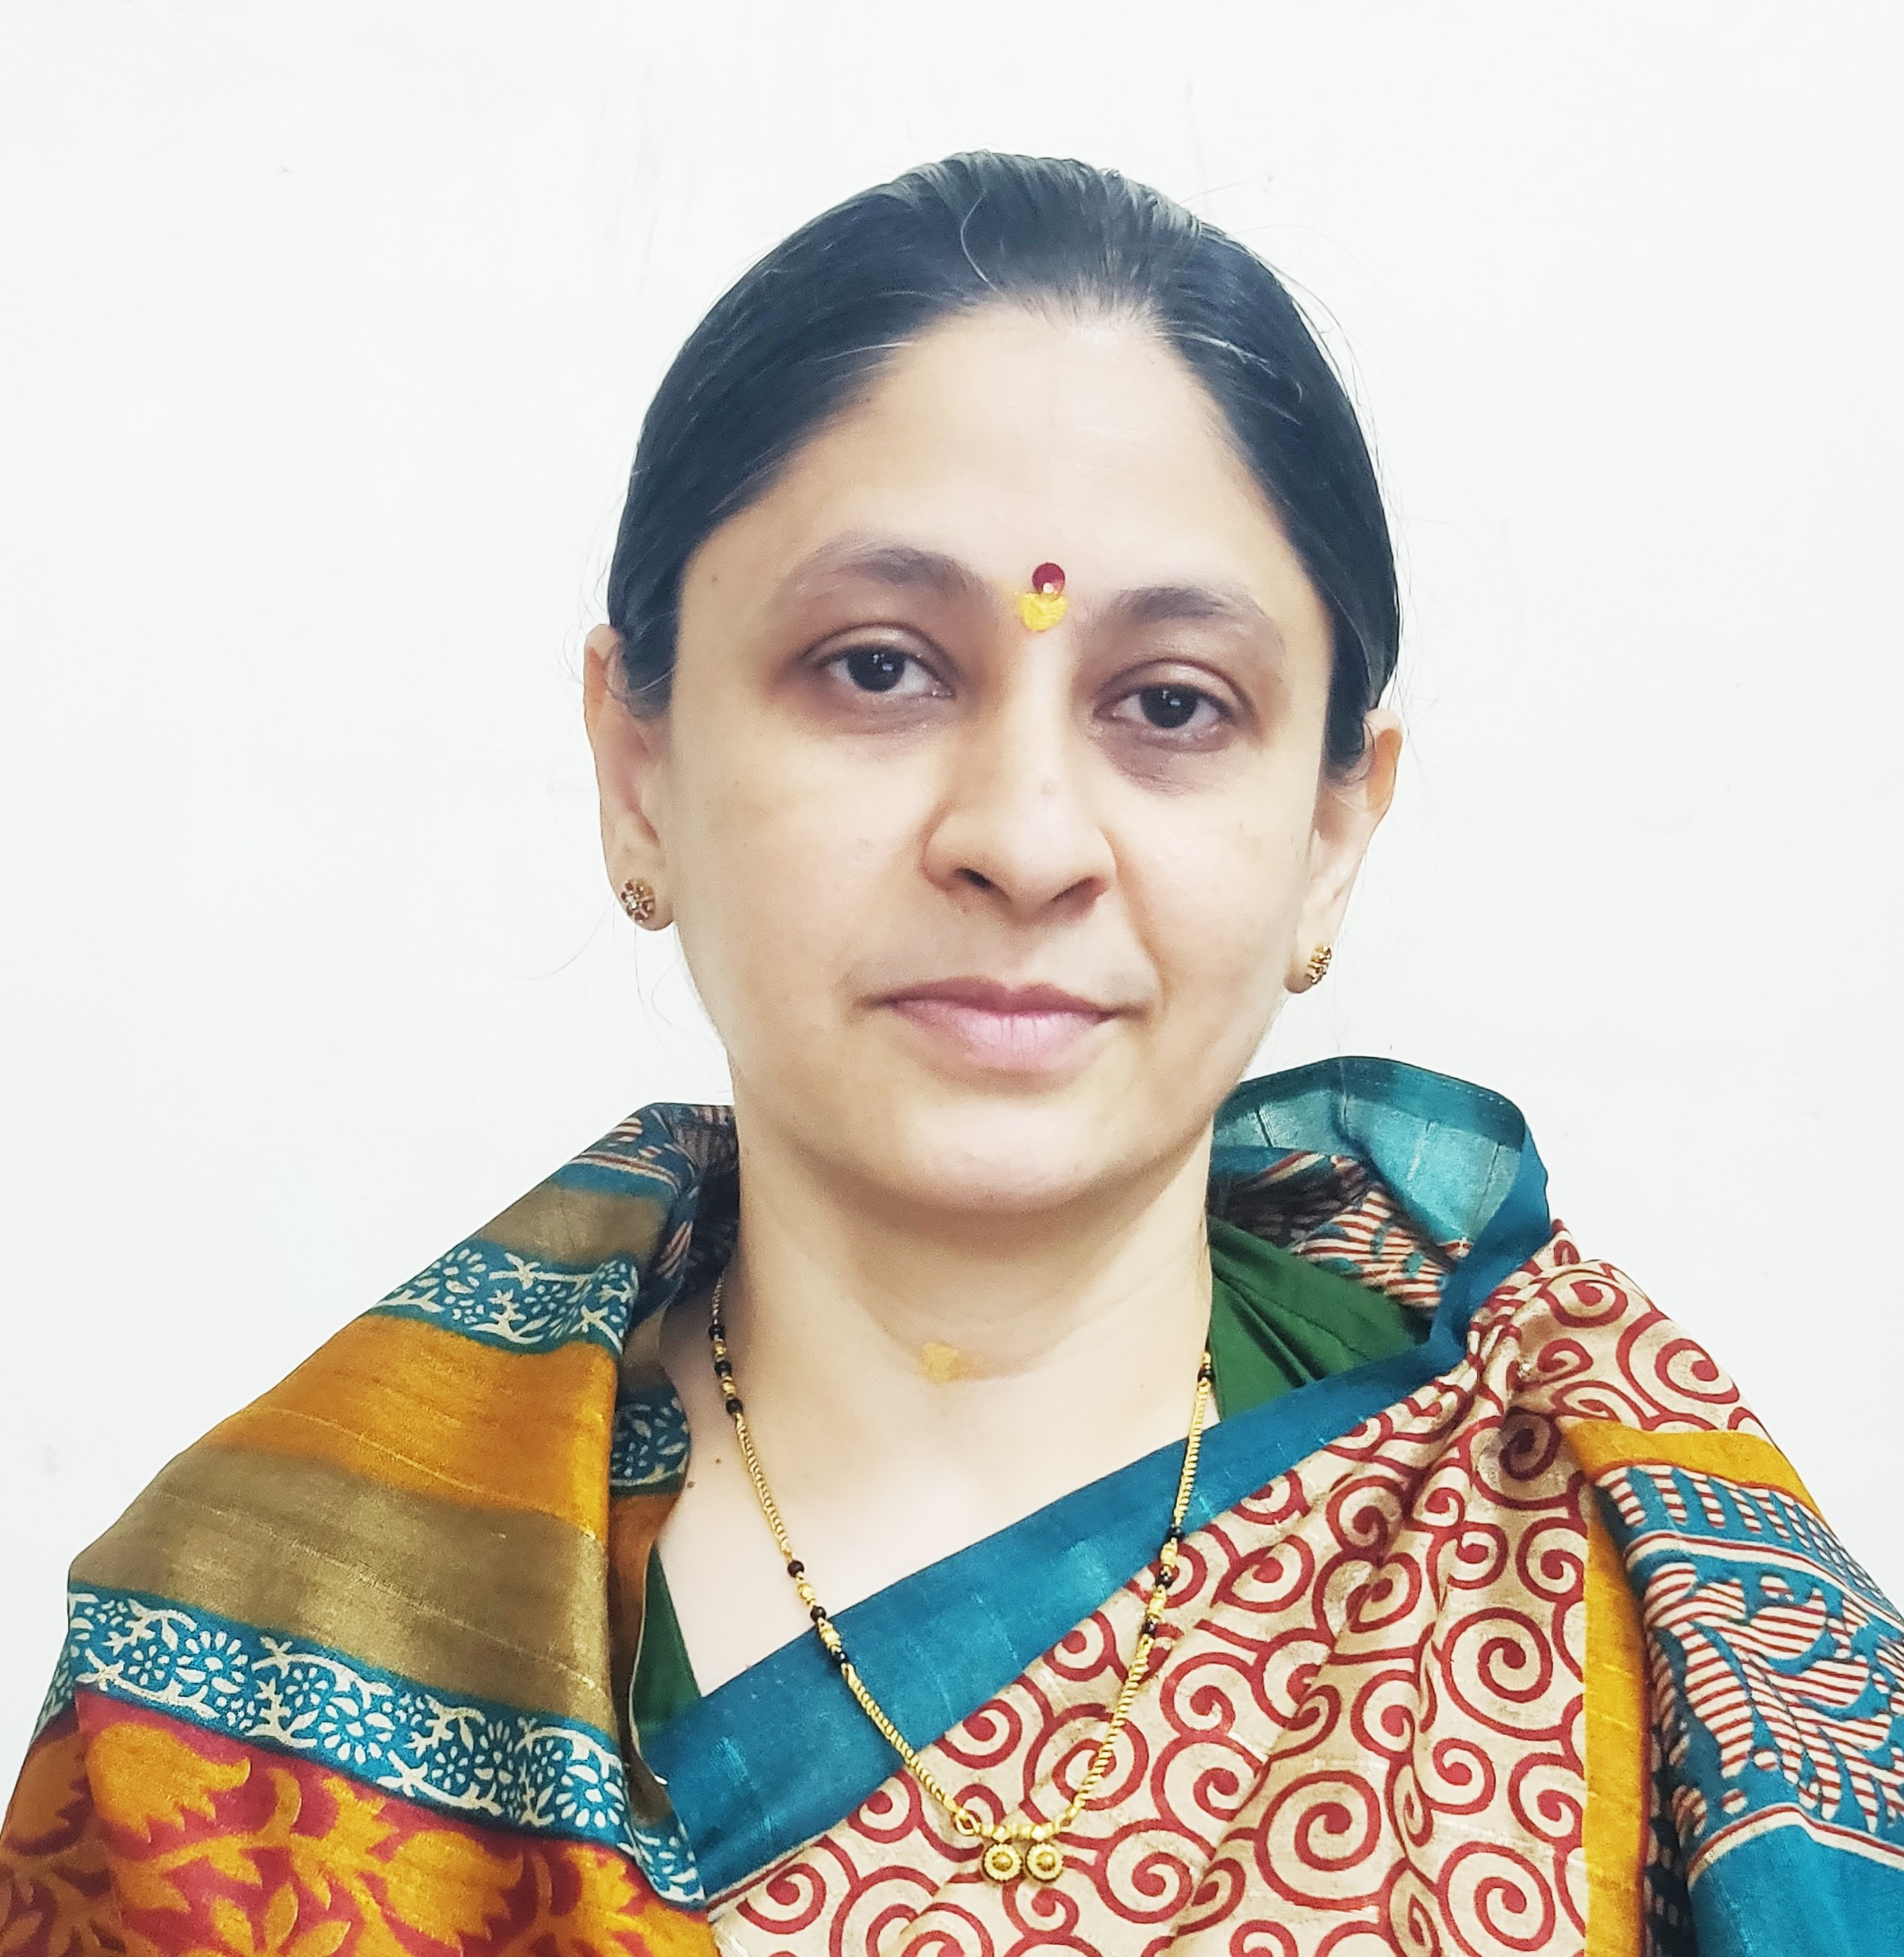

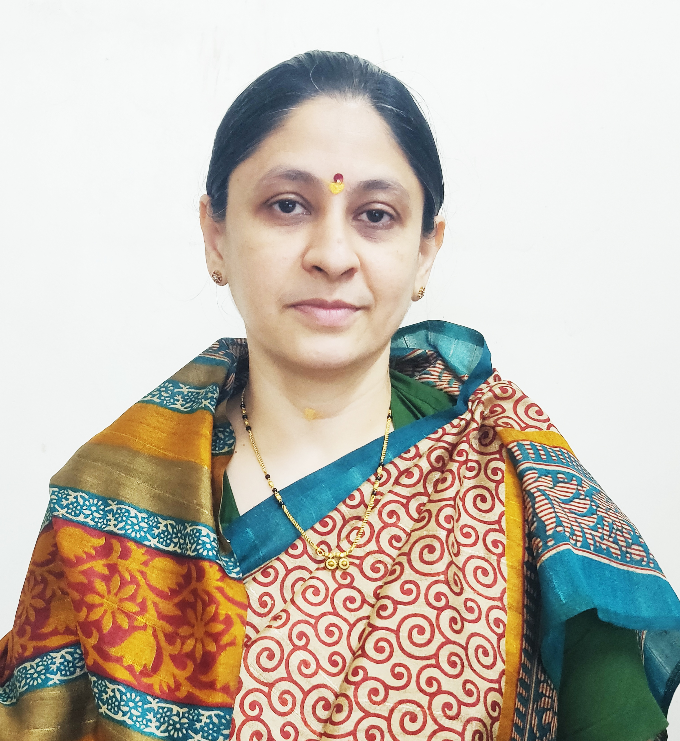

Photo

1. **General Information:**
   1. Name : Shaikh Arshad Anwar
   2. Designation : Assistant Professor in Commerce
   3. Date of Birth : 29th January, 1992
   4. Educational Qualifications: M. com, SET (Commerce)
   5. Present Pay Scale : CHB Grantable
   6. Subject : Commerce
   7. Area of Specialization : Advanced Accounting and Taxation
   8. E-mail Id : arshads223@gmail.com
   9. PAN : GDXPS4239D
   10. Phone No. : 8698352353
   11. B.C.U.D. Profile Username: 52111800092
   12. HRMS Employee Code : NA
   13. Permanent Address : Millat Nagar, Ward NO. 1, Shrirampur.
   14. Aadhar Card Number : 8479- 8211 -4360
2. **Academic Qualifications:**

|  |  |  |  |
| --- | --- | --- | --- |
| **Degree** | **Board/University** | **YearofPassing** | **%ofMarks** |
| **S.S. C.** | Maharashtra Board | 2007 | 63.53% |
| **H.S.C.** | Maharashtra Board | 2009 | 69.50% |
| **B.Com.** | University of Pune | 2012 | 77.75% |
| **M. Com.** | University of Pune | 2014 | 72.56% |
| **SET (Commerce)** | University of Pune | 2018 | Qualified |

1. **Teaching Experience (Commerce):**

|  |  |  |
| --- | --- | --- |
| Date of Appointment in Rayat Shikshan Sanstha, Satara | **Teaching Experience**  **(Years)** | **Research Experience**  **(Years)** |
| **18th June, 2018** | **07 Years** | NA |

1. **Details of Services in Sanstha:**

|  |  |  |  |
| --- | --- | --- | --- |
| **Sr.**  **No.** | **Name of the College** | **Period of Service** | |
| **From** | **To** |
| 1. | C. D. Jain College of Commerce, Shrirampur | 18th June, 2018 | Till Date |

1. **I. Research Papers Published:**

|  |  |  |  |  |  |  |
| --- | --- | --- | --- | --- | --- | --- |
| **S.N.** | **Title of the Paper** | **Journal** | **Issue** | **ISSN No** | **Page No.** | **Citations** |
| 1 | Study of Corporate Social Responsibility and its Applicability | Education and Society - Indian Institute of Education | I / Volume - III | 2278 -6864 | 329 | UGC Care Listed |
| 2 | The Study of Rural Entrepreneurship and its Promotion | International Journal of Economics, Business, Accounting, Agriculture and Management towards Paradigm Shift in Research (IJEBAMPSR), | 1 / Volume - 2 | 3065-9140 | 80 | - |
| 3 | Study of Accounting Standard on Valuation on Inventory | - | - | - | - | - |

**II. Articles / Chapters published in books:**

|  |  |  |  |  |  |  |
| --- | --- | --- | --- | --- | --- | --- |
| **Sr.**  **No.** | **Title with page no.** | **Journal** | **ISSN / ISBN** | **Impact Factor** | **Peer Reviewed** | **Citations** |
| 1 | Rashtra Sant Gadage Maharaj – Page No 61 – 17th December, 2022 | Desh Aani Videshatil Vividh Kshetratil Purush KartutwacheYogdaan | ISBN 978-93-91033-77-4 | NA | NA | NA |

1. **Training Programmes attended: (Orientation/ Refresher/ Short Term Courses/ Faculty Development Courses)**

|  |  |  |  |
| --- | --- | --- | --- |
| **Sr.**  **No.** | **Theme of Course** | **Organised by** | **Duration** |
| 1 | Orientation and Sensitisation Programme on NEP 2020 | Dr Babasaheb Ambedkar Marathwada University, Chhatrapati Sambhajinagar, UGC-Malviya Mission Teacher Training Centre | 21st April, 2025 to 30th April, 2025. |
| 2 | Faculty Development Programme in Artificial Intelligence | C. D. Jain College of Commerce, Shrirampur | 16th June, 2025 to 21st June, 2025 |

**VII. Details of Seminars/Conference/Workshops/Symposia attended:**

* **SEMINARS:**

|  |  |  |  |  |  |  |
| --- | --- | --- | --- | --- | --- | --- |
| **Sr.**  **No.** | | **Theme of Seminar/**  **Workshop** | **Organised by** | **Attended/**  **Presented Paper** | **Level** | **Date** |
| 1 | New Trends in Inventory Management | | C. D. Jain College of Commerce, Shrirampur | Attended | National | 14th to 15th December, 2019 |
| 2 | Intellectual Property right & Research Methodology | | C. D. Jain College of Commerce, Shrirampur | Attended | State | 12th February, 2020 |

* **CONFERENCES:**

|  |  |  |  |  |  |
| --- | --- | --- | --- | --- | --- |
| **Sr.**  **No.** | **Theme of Conference** | **Organised by** | **Attendance/**  **Presentation** | **Level** | **Date** |
| 1 | Recent Trends in Commerce, Economics and Management (RTCEM 2025) | SSGM Science, Gautam Arts and Sanjivani Commerce College, Kopargaon | Attended | National level E- Conference | 18th March, 2025 |

* WORKSHOPS:

|  |  |  |  |  |
| --- | --- | --- | --- | --- |
| **Sr.**  **No.** | **Theme of Seminar/ Workshop** | **Organised by** | **Capacity** | **Date** |
| 1 | One Day Workshop on Research Methodology | C. D. Jain College of Commerce, Shrirampur | One Day | 7th February, 2024 |
| 2 | One Day Workshop on NEP 2020 | C. D. Jain College of Commerce, Shrirampur | One Day | 25th June, 2024 |
| 3 | One Day Workshop on Masterclass on Development of Growth Mindset | Karmaveer Bhaurao Patil Research Foundation, Satara | One Day | 01st October, 2024 |

1. **Papers Published in Conferences Proceedings:**

|  |  |  |  |  |  |  |
| --- | --- | --- | --- | --- | --- | --- |
| **S.N.** | **Name of the Conference** | **Title of the Paper** | **Level** | **ISSN No.** | **Place** | **Pg. No.** |
| 1 | Desh aani Videshatil Vividh Kshetratil Purush Kartutwache Yogdaan | Rashtra Sant Gadage Maharaj – Page No 61 – 17th December, 2022 | 23rd International Interdisciplinary Conferrence, Pune | ISBN 978-93-91033-77-4 | Pune | 61 |

1. **Lectures Delivered: -**

|  |  |  |  |
| --- | --- | --- | --- |
| **Sr.**  **No.** | **Topic of Lecture** | **Organised by** | **Programme** |
| 1. | Awareness about NEP 2020 | C. D. Jain College of Commerce, Shrirampur -Yashwant High School and Junior College, Padhegaon – (Faculty Exchange Programme) | School Connect 2.0 (Faculty Exchange Programme) |

1. **Any Other Information**

* 1. Centre for Innovation,Incubation and Entrepreneurship Development (CIIED) – Coordinator.
  2. T.Y.B.COM. Admission Committee – Chairman.
  3. NAAC Criterion VII – Member

I hereby declare that all the information given above is true to the best of my knowledge.

Mr. Arshad Shaikh

DATE: 10th July, 2025 NAME OF THE TEACH