**Curriculum Vitae/ Profile**

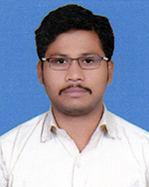 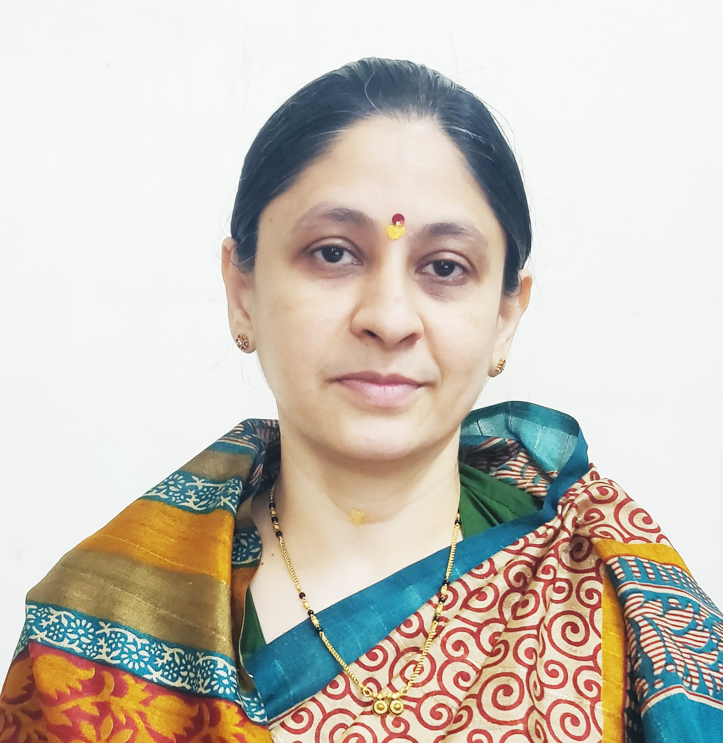

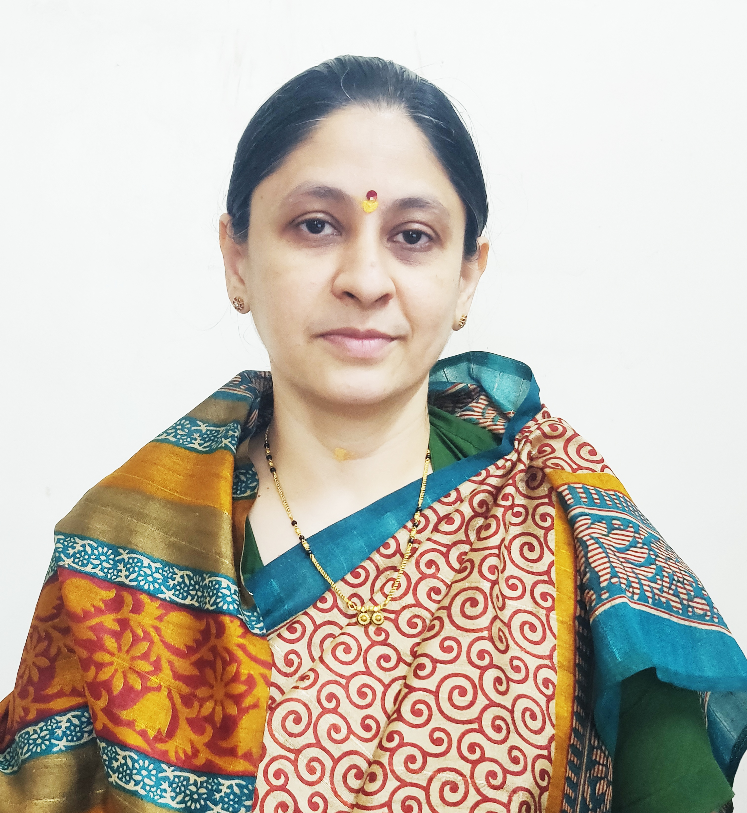

Photo

1. **General Information:**
   1. Name : Mr Datir Kailas Raghunath.
   2. Designation : Assistant Professor in Commerce
   3. Date of Birth : 27/05/1987
   4. Educational Qualifications: M. com, SET (Commerce),
   5. Present Pay Scale : CHB Grantable
   6. Subject : Commerce
   7. Area of Specialization : Cost and works Accounting
   8. E-mail Id : krdatir@gmail.com
   9. PAN : BATPD9254K
   10. PhoneNo. : 9822582864
   11. B.C.U.D. Profile Username: 52201798354
   12. HRMS Employee Code : NA
   13. Permanent Address : A/P Nipaniwadgaon Tal-Shrirampur.
   14. Aadhar Card Number 803177288972
2. **Academic Qualifications:**

|  |  |  |  |
| --- | --- | --- | --- |
| **Degree** | **Board/University** | **YearofPassing** | **%ofMarks** |
| **S.S. C.** | Maharashtra Board | 2002 | 69.73% |
| **H.S.C.** | Maharashtra Board | 2004 | 71.00 |
| **B.Com.** | University of Pune | 2007 | 76.33 |
| **M. Com.** | University of Pune | 2009 | 71.00 |
| **P.G.D.B.M** | University of Pune | 2009 | 70.33 |
| **G.D.C & A** | G.D.C.& A Board Pune | 2012 | 56.6 |
| **SET (Commerce)** | UGC | 2016 | Qualified |

1. **Teaching Experience (Commerce):**

|  |  |  |
| --- | --- | --- |
| Date of Appointment in Rayat Shikshan Sanstha, Satara | **Teaching Experience**  **(Years)** | **Research Experience**  **(Years)** |
| **21th July, 2017** | **8 Years** | NA |

1. **Details of Services in Sanstha:**

|  |  |  |  |
| --- | --- | --- | --- |
| **Sr.**  **No.** | **Name of the College** | **Period of Service** | |
| **From** | **To** |
| 1. | C. D. Jain College of Commerce, Shrirampur | 21th July, 2017 | Till Date |

1. **Research Papers Published:**

|  |  |  |  |  |  |  |
| --- | --- | --- | --- | --- | --- | --- |
| **S.N.** | **Title of the Paper** | **Journal** | **Issue** | **ISSN No** | **Page No.** | **Citations** |
| 1 | To Study the Methods Available For Inventory Management | International Journal of Management and Economics | 27 | 2331-4687 | 22 | Impact Factor – 6.81 |
| 2 | To Study the Methods Available For Inventory Cost Control | International Journal of Management and Economics | 27 | 2331-4687 | 24 | Impact Factor – 6.81 |
| 3 | E-Commerce in India :Challenges and Opportunities | Strengthening Business Competencies For Sustainable Development | 235B | 2348-7143 | 34 | Impact Factor – 6.625 |
| 4 | To Study the Recent Trends in Financial Management | Akshay Kalit – UGC Care listed Journal Humanities social Science and Fine Arts | 9 | 2277-419X | 2944 | - |
| 5 | To Study of Emerging Trends in E-Banking Service in India | Education & Society – 27th – 28th January, 2023 | I/IV | 2278-6864 | 28 | UGC Care Listed |

1. **Articles/ Chapters published in books:**

|  |  |  |  |  |  |  |
| --- | --- | --- | --- | --- | --- | --- |
| **Sr.**  **No.** | **Title with page no.** | **Journal** | **ISSN / ISBN** | **Impact Factor** | **Peer Reviewed** | **Citations** |
| 1 | Me Pahilela Ek Udyojak | Desh Aani Videshatil Vividh Kshetratil Purush KartutwacheYogdaan | ISBN 978-93-91033-77-4 | NA | NA | NA |
| 2 | Me Pahilele Ek Udyojak –Aanand Mahindra | The Contribution of National and International Personalities in The Making of Modern India | - | NA | NA | NA |

1. **Training Programmes attended: (Orientation/ Refresher/ Short Term Courses/ Faculty Development Courses)**

|  |  |  |  |
| --- | --- | --- | --- |
| **Sr.**  **No.** | **Theme of Course** | **Organised by** | **Duration** |
| 1. | Faculty Development Programme in Artificial Intelligence | C. D. Jain College of Commerce, Shrirampur | 16th June, 2025 to 21st June, 2025 |

1. **Details of Seminars/Conference/Workshops/Symposia attended:**

* **SEMINARS:**

|  |  |  |  |  |  |  |
| --- | --- | --- | --- | --- | --- | --- |
| **Sr.**  **No.** | | **Theme of Seminar/**  **Workshop** | **Organised by** | **Attended/**  **PresentedPaper** | **Level** | **Date** |
| 1 | NA | | NA | NA | NA | NA |

* **CONFERENCES:**

|  |  |  |  |  |  |
| --- | --- | --- | --- | --- | --- |
| **Sr.**  **No.** | **Theme of Conference** | **Organised by** | **Attendance/**  **Presentation** | **Level** | **Date** |
| 1 | Akshay Kalit – Transforming Challenges in Business Opportunities | SSGM Science, Gautam Arts and Sanjivani Commerce College, Kopargaon | Attended | International Level Virtual Conference | 29th to 30th March |
| 2 | India @75: Sustainable Development through Commerce and Management | Karmveer Bhaurao Patil Mahavidyalaya, Pandharpur | Attended | UGC CARE Listed Journal - | 27th – 28th January, 2023 |

WORKSHOPS:

|  |  |  |  |  |
| --- | --- | --- | --- | --- |
| **Sr.**  **No.** | **Theme of Seminar/ Workshop** | **Organised by** | **Capacity** | **Date** |
| 1 | One Day Workshop on Research Methodology | C. D. Jain College of Commerce, Shrirampur | One Day | 7th February, 2024 |
| 2 | One Day Workshop on NEP 2020 | C. D. Jain College of Commerce, Shrirampur | One Day | 25th June, 2024 |

1. **Papers Published in Conferences Proceedings:**

|  |  |  |  |  |  |  |
| --- | --- | --- | --- | --- | --- | --- |
| **S.N.** | **Name of the Conference** | **Title of the Paper** | **Level** | **ISSN No.** | **Place** | **Pg. No.** |
| 1 | Desh aani Videshatil Vividh Kshetratil Purush Kartutwache Yogdaan | Me Pahilela Ek Udyojak | 23rd International Interdisciplinary Conferrence, Pune | ISBN 978-93-91033-77-4 | Pune | 30 |
| 2 | The Contribution of National and International Personalities in the Making of Modern India | Me Pahilela Udyojak- Aanand Mahindra | 29th International Interdisciplinary Conferrence, Pune | - | Pune | - |

1. **Participation in Corporate life /Extension work/ Community Services:**

|  |  |  |  |  |
| --- | --- | --- | --- | --- |
| **Sr.No** | **Position held** | **Name of the Authority** | **From** | **To** |
| 1. | Accountant | Panchayat Samiti Rahuri | 20/07/2010 | 30/04/2016 |

1. **Lectures Delivered:-**

|  |  |  |  |
| --- | --- | --- | --- |
| **Sr.**  **No.** | **Topic of Lecture** | **Organised by** | **Programme** |
| 1. | Awareness about NEP 2020 | Aart,commerce and science college,Ashoknagar | School Connect 2.0 (Faculty Exchange Programme) |

1. **Any Other Information**
   1. NAAC Criterion I – Chairman.
   2. Short Term Course Department – Coordinator.
   3. Programm Officer National Service Scheme.

I hereby declare that all the information given above is true to the best of my knowledge.

Mr.Datir Kailas Raghunath.

DATE: 10th July, 2025 NAME OF THE TEACHER