**Curriculum Vitae / Profile**

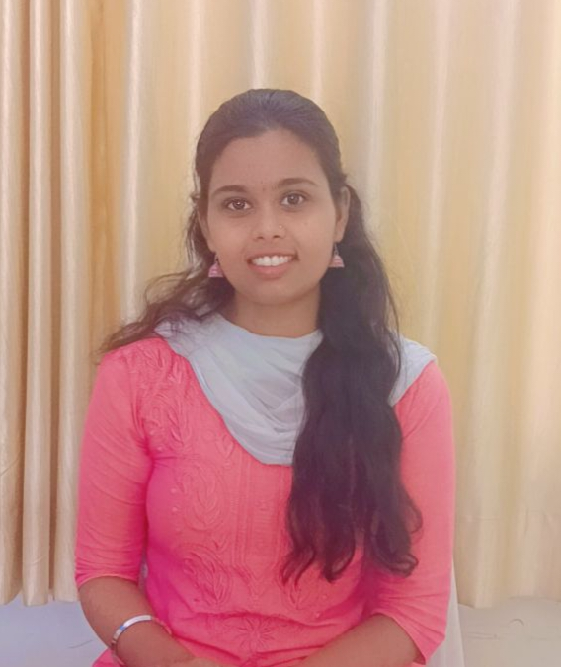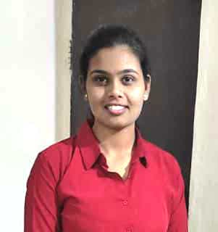

1. **General Information:**
2. Name : Miss. Jejurkar Mayuri Shivaji
3. Designation : Assistant Professor
4. Date of Birth : 10/07/1999
5. Educational Qualifications : NET, SET, M. Com
6. Present Pay Scale : CHB Grantable
7. Subject : Commerce
8. Area of specialization : Accountancy
9. E-mail Id : mayurijejurkar1@gmail.com
10. PAN : BSZPJ1663C
11. Phone No. : 8080680003
12. B.C.U.D. Profile Username : 52082400246
13. HRMS Employee Code : NA
14. Permanent Address : Shri Sai Samarth apartment, Purnvadnagar, Shrirampur 413709
15. Aadhar Card Number : 447480087134

**II . Academic Qualifications:**

|  |  |  |  |
| --- | --- | --- | --- |
| **Degree** | **Board/ University** | **Year of Passing** | **% of Marks** |
| **S. S. C.** | Pune Board | 2014 | 70.60 |
| **H. S. C.** | Maharashtra state Board | 2016 | 80.92 |
| **B. Com** | Savitribai Phule Pune University | 2019 | 72.25 |
| **M. Com** | Savitribai Phule Pune University | 2021 | 9.33(CGPA) |
| **NET** | UGC | 2022 | 93 |
| **Ph. D.** | Savitribai Phule Pune University | -- | -- |

1. **Teaching Experience :**

|  |  |  |
| --- | --- | --- |
| Date of Appointment in Rayat Shikshan Sanstha, Satara | **Teaching**  **Experience**  **(Years)** | **Research**  **Experience**  **(Years)** |
| **11 August 2022** | 2 | NA |

**V. Details of Services in Sanstha:**

|  |  |  |  |
| --- | --- | --- | --- |
| **Sr.**  **No.** | **Name of the College** | **Period of Service** | |
| **From** | **To** |
|  | C. D. Jain College of Commerce, Shrirampur | 11/08/2022 | Up till Date |

**IX. Research Papers Published:**

|  |  |  |  |  |  |  |
| --- | --- | --- | --- | --- | --- | --- |
| **Sr.No.** | **Title of the Paper** | **Journal** | **Issue** | **ISSN No** | **Page No.** | **Citations** |
| 1 | A Study on Recent Trend in Commerce | Education and Society | March-2023 | ISSN-2278-6864 | - | - |
| 2. | Optimizing Organizational excellence: An in-Depth examination of Human resources Audit Methodologies and Their role in ensuring Sustainable Business Success | National Journal of Research in Marketing Finance and HRM | Issue -2 | ISSN-2455-5398 | - | - |
| 3 | The Role of Indian Knowledge System (IKS) in Development of India | International Journal of Economics, Business, Accounting, Agriculture and Management Towards Paradigm Shift in Research | April - 2025 | ISSN - 3065-9140 | - | - |

**XII. Training Programmes attended: (Orientation/ Refresher/ Short Term Courses/Faculty Development Courses)**

|  |  |  |  |
| --- | --- | --- | --- |
| **Sr.No.** | **Theme of Course** | **Organised by** | **Duration** |
| 1. | Faculty Development Programme in Artificial Intelligence | C. D. Jain College of Commerce Shrirampur | 16- 21 June, 2025 |
|  | NEP 2020 Orientation and Sensitization Programm | UGC- Malaviya Mission Teachers Training Centre | 21-30 April, 2025 |

**XIII. Details of Seminars/Conference/Workshops/Symposia attended:**

* **SEMINARS:**

|  |  |  |  |  |
| --- | --- | --- | --- | --- |
| **Sr.No.** | **Theme of Seminar/ Workshop** | **Organised by** | **Attended/ Presented Paper** | **Date** |
| 1 | Introduction to IKS Under NEP 2020 | Department of History, SPPU | Attended |  |

* **CONFERENCES:**

|  |  |  |  |  |  |
| --- | --- | --- | --- | --- | --- |
| **Sr.No.** | **Theme of Conference** | **Organised by** | **Attendance/ Presentation** | **Level** | **Date** |
| 1. | Recent Trends in Commerce, Economics and Management (RTCEM 2025) | SSGM Science, Gautam Arts and sanjivani Commerce College, Kopargaon | Attended | National level E- Conference | 18 March,2025 |

**XIV. Papers Published in Conferences proceedings:**

|  |  |  |  |  |  |
| --- | --- | --- | --- | --- | --- |
| **S.N.** | **Name of the Conference** | **Title of the Paper** | **ISSN No.** | **Place** | **Pg. No.** |
| 1 | The Contribution and Achievements of Men in Various spheres at National and International Levels | Dr. Kishor Jagtap A Visionary Academic And International Contribution to Modern India | ISBN-978-9391033-77-4 | Pune | - |

**XVIII. Lectures Delivered:-**

|  |  |  |  |
| --- | --- | --- | --- |
| **Sr.No.** | **Topic of Lecture** | **Organised by** | **Programme** |
| 1. | Awareness about NEP 2020 | C. D. Jain College of Commerce with Dahanukar Science and Conmmerce College, Tilaknagar (Faculty Exchange Program) | School Connect 2.0(Faculty Exchange Program) |

**XIX. Any other information**

1.NAAC Criterion II- Member

2. CA/CS/CMA Guidance Centre- Coordinator

3. M.Com-I. Admission Committee - Member.

I hereby declare that all the information given above is true to the best of my knowledge.

**DATE: 10th July, 2025**

**Miss. Mayuri Jejurkar**