**Curriculum Vitae/ Profile**

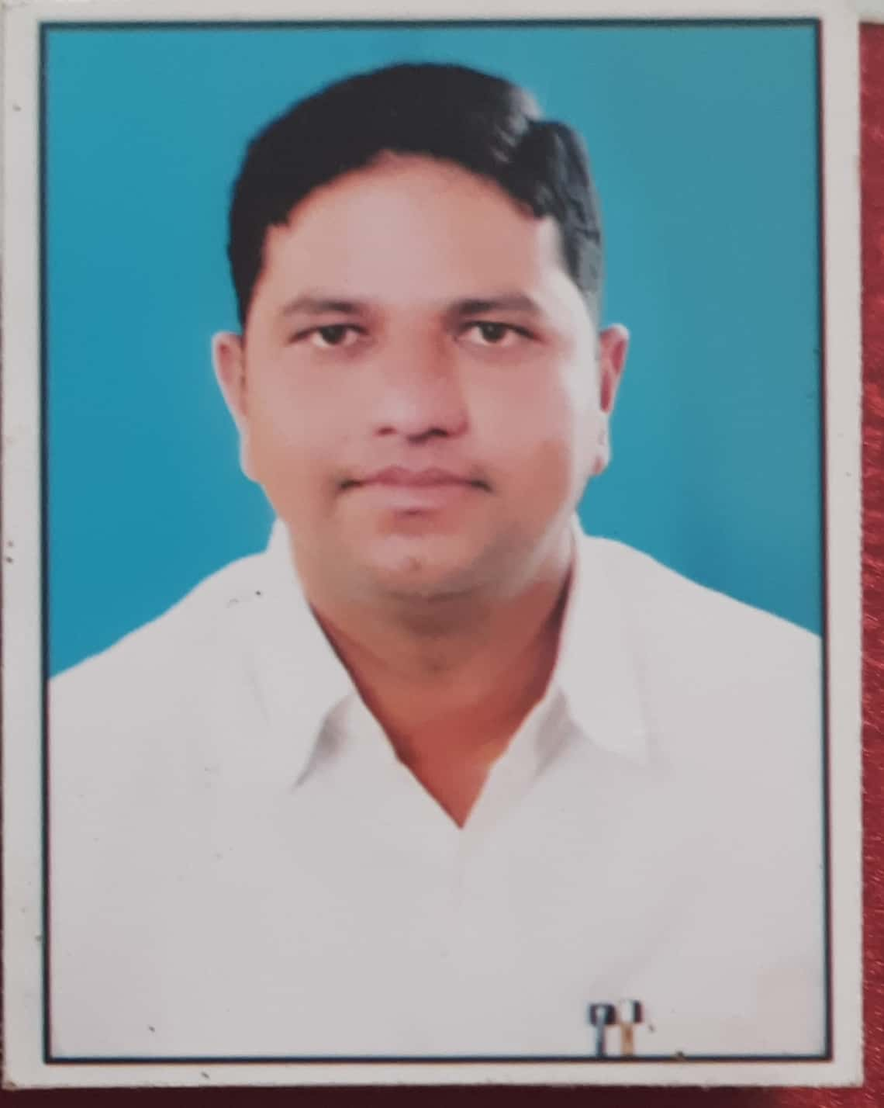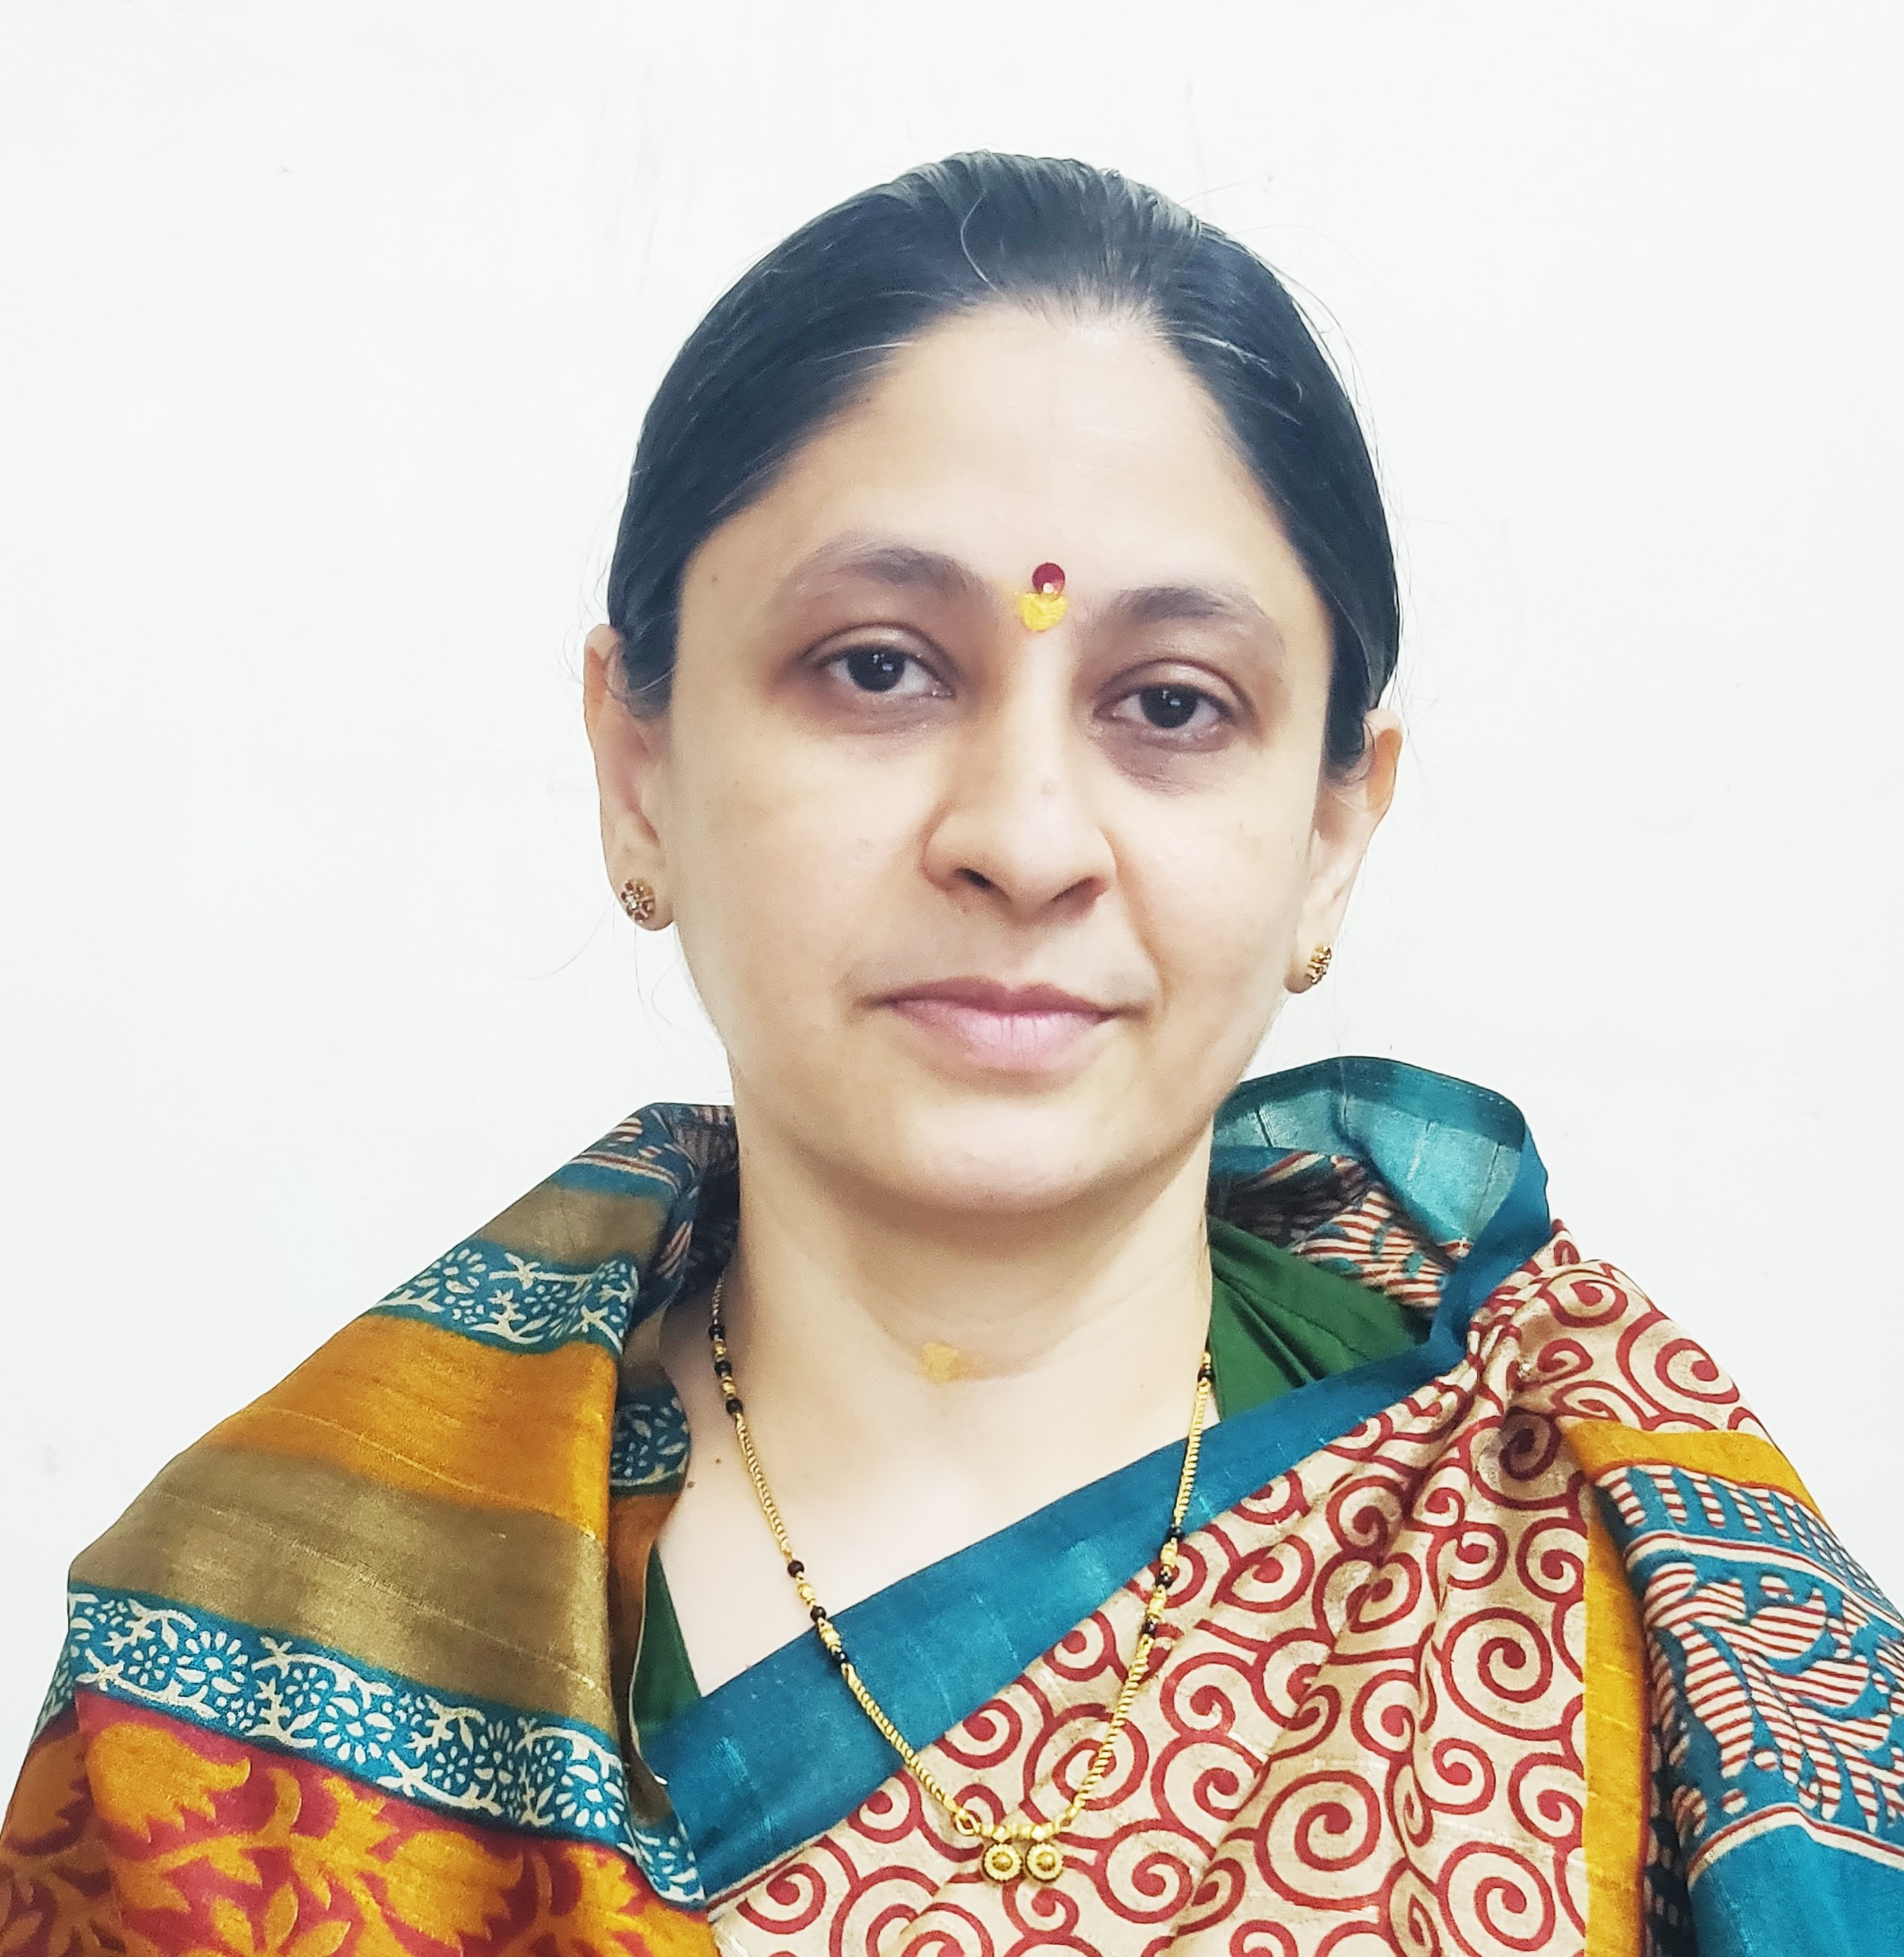

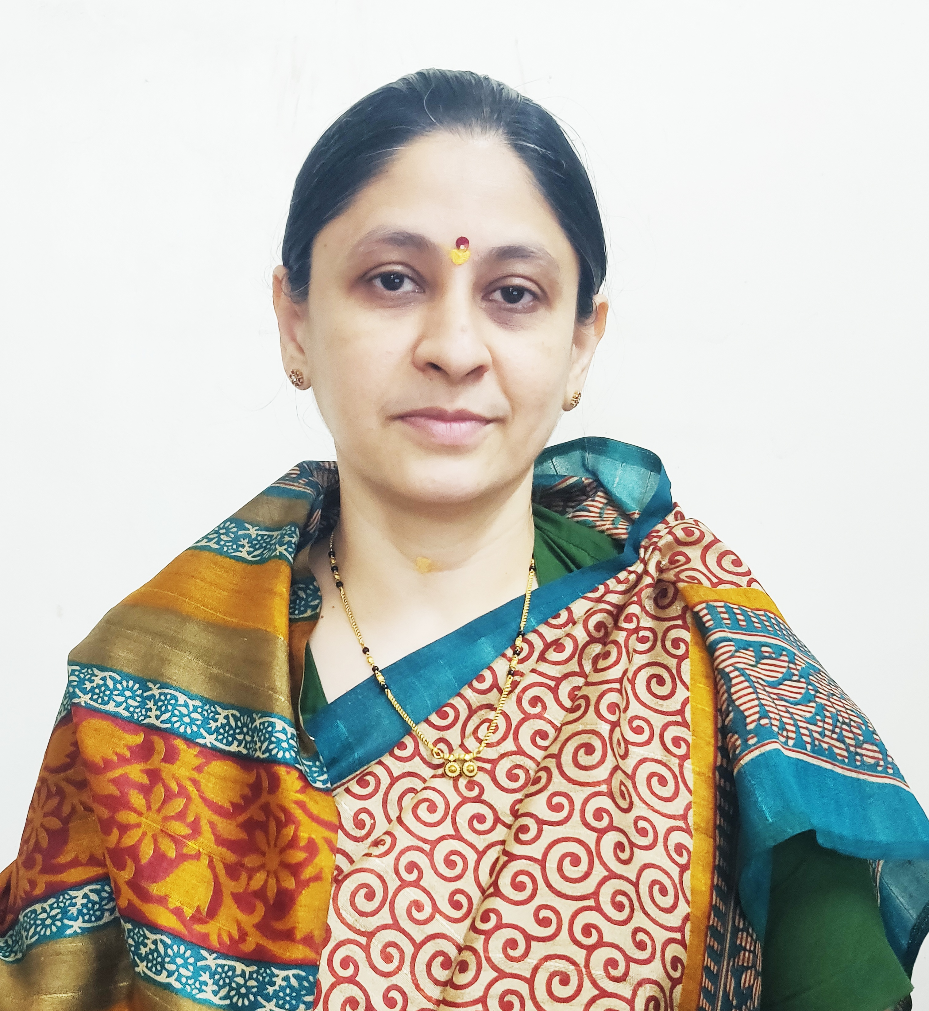

Photo

1. **General Information:**
   1. Name : Mr. Arun Parasram Kadam
   2. Designation : Assistant Professor in Commerce
   3. Date of Birth : 09th Sepetember 1988
   4. Educational Qualifications: M. com, SET (Commerce), MA Economics ,MBA, GDC&A B.ed.
   5. Present Pay Scale : CHB Grantable
   6. Subject : Commerce
   7. Area of Specialization : Business Administration
   8. E-mail Id : arunkadam777@gmail.com
   9. PAN : BHDPK8212P
   10. Phone No. : 9823972556
   11. B.C.U.D. Profile Username: 52092400134
   12. HRMS Employee Code : NA
   13. Permanent Address : At Post Padhegaon, Kopargaon , Taluka
   14. Aadhar Card Number : 5312-0849-4103
2. **Academic Qualifications:**

|  |  |  |  |
| --- | --- | --- | --- |
| **Degree** | **Board/University** | **YearofPassing** | **% of Marks** |
| **S.S. C.** | Maharashtra Board | 2004 | 52.40% |
| **H.S.C.** | Maharashtra Board | 2006 | 61.17% |
| **B.Com.** | University of Pune | 2009 | 61.41% |
| **M. Com.** | University of Pune | 2012 | 61.50% |
| **B.Ed.** | University of Pune | 2012 | 63.75% |
| **SET (Commerce)** | SPPU | 2024 | Qualified |
| **MBA** | YCMOU | 2017 | 50.09% |
| **MA Economics** | SPPU | 2015 | 56.81% |
| **GDC&A** | Maharashtra Government | 2011 | 57.50% |

1. **Teaching Experience (Commerce):**

|  |  |  |
| --- | --- | --- |
| Date of Appointment in Rayat Shikshan Sanstha, Satara | **Teaching Experience**  **(Years)** | **Research Experience**  **(Years)** |
| **08-10-2024** | **01 Year** | NA |

1. **Details of Services in Sanstha:**

|  |  |  |  |
| --- | --- | --- | --- |
| **Sr.**  **No.** | **Name of the College** | **Period of Service** | |
| **From** | **To** |
| 1. | C. D. Jain College of Commerce, Shrirampur | **08-10-2024** | Till Date |

1. **Training Programmes attended: (Orientation/ Refresher/ Short Term Courses/ Faculty Development Courses)**

|  |  |  |  |
| --- | --- | --- | --- |
| **Sr.**  **No.** | **Theme of Course** | **Organised by** | **Duration** |
| 1. | Faculty Development Programme in Artificial Intelligence | C. D. Jain College of Commerce, Shrirampur | 16th June, 2025 to 21st June, 2025 |

1. **Lectures Delivered:-**

|  |  |  |  |
| --- | --- | --- | --- |
| **Sr.**  **No.** | **Topic of Lecture** | **Organised by** | **Programme** |
| 1. | Awareness about NEP 2020 | C. D. Jain College of Commerce, Shrirampur - Mahale Kanishtha Mahavidyalay, Ainatpur – (Faculty Exchange Programme) | School Connect 2.0 (Faculty Exchange Programme) |

1. **Any Other Information**
   1. NAAC Criterion VI – Member
   2. TYBCOM Admission Committee – Member.

I hereby declare that all the information given above is true to the best of my knowledge.

Arun Parasram Kadam

DATE: 10th July, 2025 NAME OF THE TEACHER