**Curriculum Vitae/ Profile**

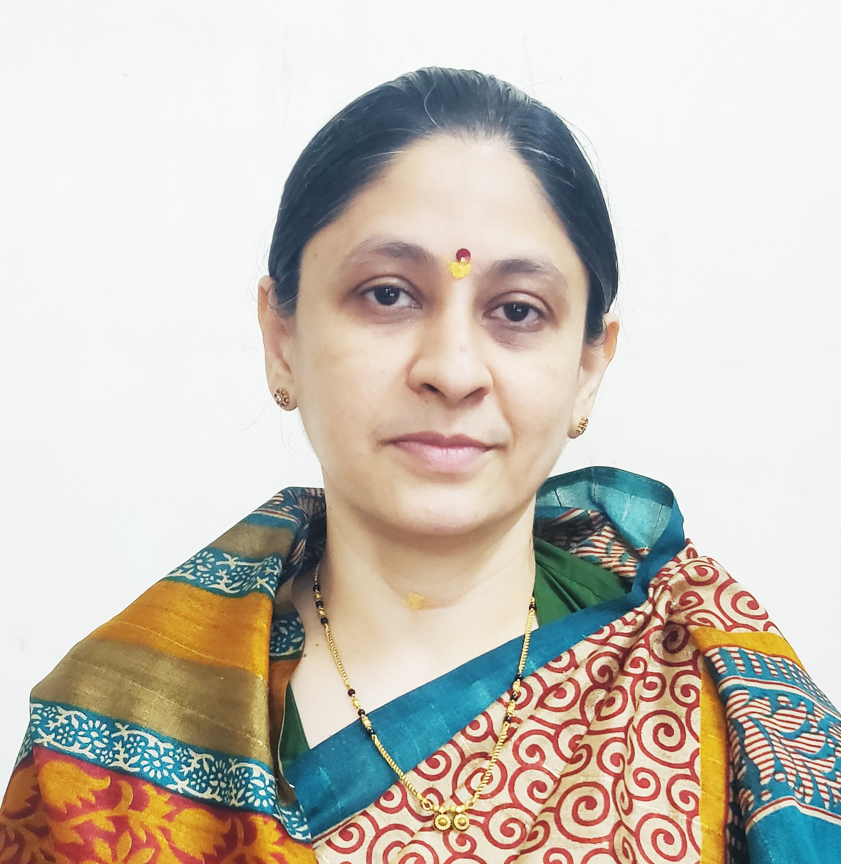

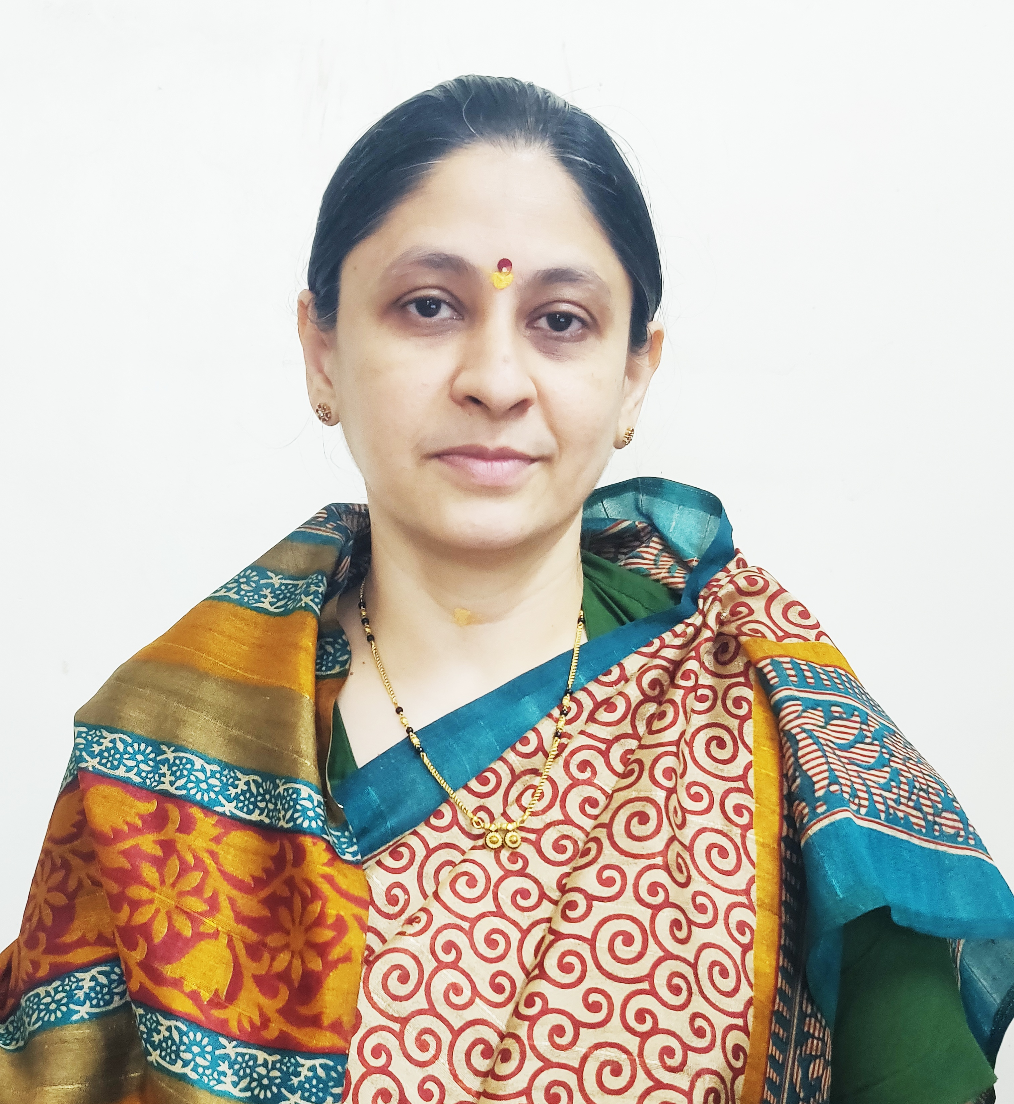

Photo

1. **General Information:**
   1. Name : Mr.Yogesh Rajabapu Labade.
   2. Designation : Assistant Professor in Commerce
   3. Date of Birth : 5th October, 1992
   4. Educational Qualifications: M. com, SET (Commerce).
   5. Present Pay Scale : CHB Grantable
   6. Subject : Commerce
   7. Area of Specialization : Business Administration
   8. E-mail Id : ylabade510@gmail.com
   9. PAN : ATGPL0147E
   10. PhoneNo. : 8698927263
   11. B.C.U.D. Profile Username: 52081800349
   12. HRMS Employee Code : NA
   13. Permanent Address : At- Madaki, Tal- Newasa, Dist-Ahilyanagar.
   14. Aadhar Card Number : 2965 9865 2177.
2. **Academic Qualifications:**

|  |  |  |  |
| --- | --- | --- | --- |
| **Degree** | **Board/University** | **Year of Passing** | **% of Marks** |
| **S.S. C.** | Maharashtra Board | 2008 | 64.00% |
| **H.S.C.** | Maharashtra Board | 2010 | 52.67% |
| **B.Com.** | University of Pune | 2014 | 65.75% |
| **M. Com.** | University of Pune | 2017 | 72.69% |
| **SET (Commerce)** | SPPU,Pune | 2018 | Qualified |

1. **Teaching Experience (Commerce):**

|  |  |  |
| --- | --- | --- |
| Date of Appointment in Jijamata college of science and arts bhende.bk. | **Teaching Experience**  **(Years)** | **Research Experience**  **(Years)** |
| **5th Jan 2018** | **7 Years** | NA |

1. **Details of Services in Sanstha:**

|  |  |  |  |
| --- | --- | --- | --- |
| **Sr.**  **No.** | **Name of the College** | **Period of Service** | |
| **From** | **To** |
| 1. | C. D. Jain College of Commerce, Shrirampur | 16th June, 2025 | Till Date |

1. **Research Papers Published:**

|  |  |  |  |  |  |  |
| --- | --- | --- | --- | --- | --- | --- |
| **S.N.** | **Title of the Paper** | **Journal** | **Issue** | **ISSN No** | **Page No.** | **Citations** |
| 1 | Study of Digital Payment System in India | AJANTA Journal | I-jan march 2019 | 2277-5730 | 82-85 | Impact Factor – 5.5 |
| 2 | A Study of E-Commerce in India | Vidyawarta. | Special issue jan 2019 | 2319-9318 | 112-114 | Impact Factor – 5.131(IIJIF) |

1. **Training Programmes attended: (Orientation/ Refresher/ Short Term Courses/ Faculty Development Courses)**

|  |  |  |  |
| --- | --- | --- | --- |
| **Sr.**  **No.** | **Theme of Course** | **Organised by** | **Duration** |
| 1. | Faculty Development Programme in Artificial Intelligence | C. D. Jain College of Commerce, Shrirampur | 16th June, 2025 to 21st June, 2025 |
| 2. |  |  |  |

1. **Details of Seminars/Conference/Workshops/Symposia attended:**

* **SEMINARS:**

|  |  |  |  |  |  |  |
| --- | --- | --- | --- | --- | --- | --- |
| **Sr.**  **No.** | | **Theme of Seminar/**  **Workshop** | **Organised by** | **Attended/**  **PresentedPaper** | **Level** | **Date** |
| 1 | Choice based credit System(CBCS) Implementation of commerce and Science Programs of Colleges affiliated to SPPU workshop | | Savitribai Phule Pune University. | Attended | University | 14th Sept, 2019 |

1. **CONFERENCES:**

|  |  |  |  |  |  |
| --- | --- | --- | --- | --- | --- |
| **Sr.**  **No.** | **Theme of Conference** | **Organised by** | **Attendance/**  **Presentation** | **Level** | **Date** |
| 1 | Recent Trends in Commerce and Management | Shri Dnyaneshwar Mahavidyalaya,Newasa | Attended | national Level | 15th to 16th Feb. 2019 |
| 2. | Innovative and Recent Trends in Commerce, Management and IT. | Arts Commerce and Science College, Sonai. | Attended | State | 22nd and 23rd Jan 2019 |

1. **Participation in Corporate life /Extension work/ Community Services:**

|  |  |  |  |  |
| --- | --- | --- | --- | --- |
| **Sr.No** | **Position held** | **Name of the Authority** | **From** | **To** |
| 1. | Co-ordinator member | NSS Jijamata College of science and arts, bhende. | 1st July, 2018 | 31st April 2025 |

1. **Any Other Information**
   1. NAAC Criterion II – Member.
   2. T.Y.B.Com. 2019 Pattern (CBCS) Admission Committee – Member

I hereby declare that all the information given above is true to the best of my knowledge.

Mr.Y.R.Labade.

DATE: 7th July, 2025 NAME OF THE TEACHER