**Curriculum Vitae/ Profile**

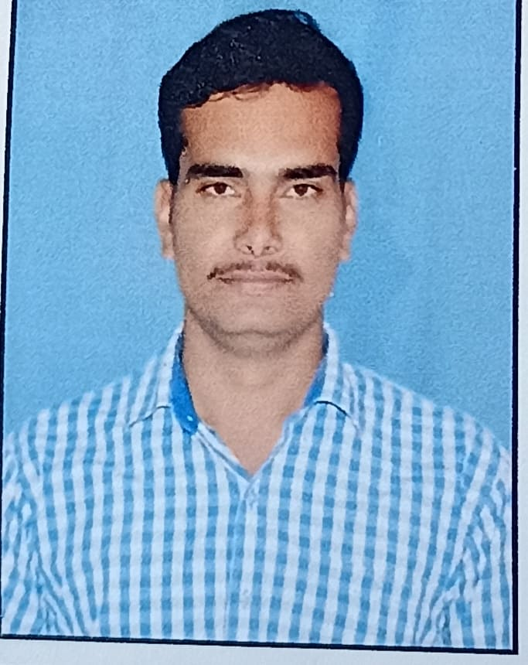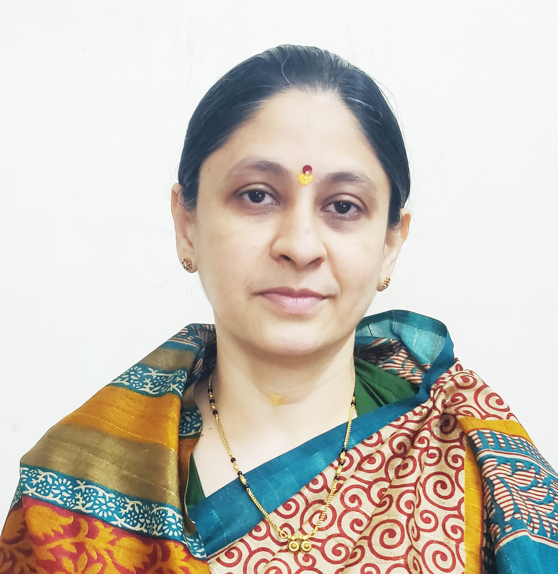

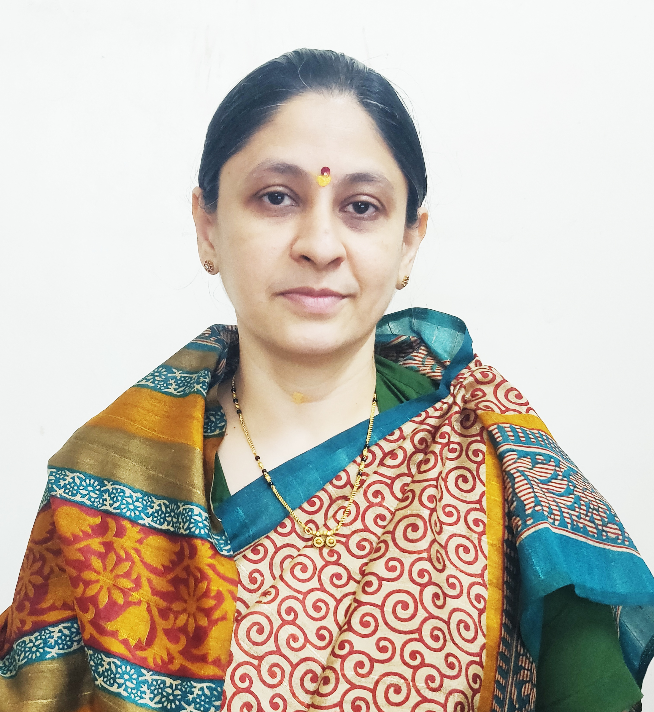

Photo

1. **General Information:**
   1. Name : Dr. Yadav Pradip Shardaprasad
   2. Designation : Assistant Professor in Commerce
   3. Date of Birth : 05th June 1994
   4. Educational Qualifications: M. com, NET (Commerce), Ph. D.
   5. Present Pay Scale : CHB Grantable
   6. Subject : Commerce
   7. Area of Specialization : Advanced Accounting and Taxation
   8. E-mail Id : pradipyadav1994@gmail.com
   9. PAN : AKHPY3491J
   10. Phone No. : 9921770206
   11. B.C.U.D. Profile Username: 52201691390
   12. HRMS Employee Code : NA
   13. Permanent Address : Yadavnagar ,Behind RBNB college,Ward No. 1, Shrirampur.
   14. Aadhar Card Number : 4328-5533-4377
2. **Academic Qualifications:**

|  |  |  |  |
| --- | --- | --- | --- |
| **Degree** | **Board/University** | **Year of Passing** | **% of Marks** |
| **S.S. C.** | Maharashtra Board | 2009 | 64.61% |
| **H.S.C.** | Maharashtra Board | 2011 | 70.83% |
| **B.Com.** | University of Pune | 2014 | 72.91% |
| **M. Com.** | Savitribai Phule Pune University Pune | 2016 | 72.08% |
| **NET (Commerce)** | UGC | 2016 | Qualified |
| **Ph.D.** | Savitribai Phule Pune University Pune | 2024 | Awarded |

1. **Teaching Experience (Commerce):**

|  |  |  |
| --- | --- | --- |
| Date of Appointment in Rayat Shikshan Sanstha, Satara | **Teaching Experience**  **(Years)** | **Research Experience**  **(Years)** |
| **08th August 2016** | **10 Years** | NA |

1. **Details of Services in Sanstha:**

|  |  |  |  |
| --- | --- | --- | --- |
| **Sr.**  **No.** | **Name of the College** | **Period of Service** | |
| **From** | **To** |
| 1. | SSGM College, Kopargaon | 08th August 2016 | 30th June 2020 |
| 2. | C. D. Jain College of Commerce, Shrirampur | 01th July, 2020 | Till Date |

1. **Research Papers Published:**

|  |  |  |  |  |  |  |
| --- | --- | --- | --- | --- | --- | --- |
| **S.N.** | **Title of the Paper** | **Journal** | **Issue** | **ISSN No** | **Page No.** | **Citations** |
| 1 | Recruitment Needs of Companies and Importance of Campus Recruitment | Research Journey International Multi-Disciplinary E-Research Journal – November 2018 | Special Issue -Samiksha | 2348-7143 | 208 | Impact Factor – 3.425 |
| 2 | The Study Role of Colleges in Students Labor Market Alignment | Akshay Kalit – Transforming Challenges in Business Opportunities – 29th to 30th March, 2022 | 9 | 2277-419X | 228 | - |
| 3 | College Students Perceptions about College Education and Their Employability Skill | Education & Society – 27th – 28th January, 2023 | I/III | 2278-6864 | 231 | UGC Care Listed |
| 4 | Strategic Role of Human Resources in Implementing NEP 2020: A Pathway to Institutional Excellence | International Journal of Economics, Business, Accounting, Agriculture and Management towards Paradigm Shift in Research (IJEBAMPSR) April 2025 | Volume 2| Issue 2 | 3065-9140 | 182 | UGC Care Listed |

1. **Articles/ Chapters published in books:**

|  |  |  |  |  |  |  |
| --- | --- | --- | --- | --- | --- | --- |
| **Sr.**  **No.** | **Title with page no.** | **Journal** | **ISSN / ISBN** | **Impact Factor** | **Peer Reviewed** | **Citations** |
| 1 | शरदचंद्रजी पवार - समताधिष्ठित नेतृत्व- 57 | Desh Aani Videshatil Vividh Kshetratil Purush KartutwacheYogdaan- December, 2022 | 978-93-91033-77-4 | NA | NA | NA |
| 2 | रतन टाटा - आधुनिक भारत निर्माणातील योगदान | The Contribution of National and International Personalities in The Making of Modern India February, 2025 | - | NA | NA | NA |

1. **Training Programmes attended: (Orientation/ Refresher/ Short Term Courses/ Faculty Development Courses)**

|  |  |  |  |
| --- | --- | --- | --- |
| **Sr.**  **No.** | **Theme of Course** | **Organised by** | **Duration** |
| 1. | Faculty Development Programme in Artificial Intelligence | C. D. Jain College of Commerce, Shrirampur | 16th June, 2025 to 21st June, 2025 |
| 2. | 19-NEP 2020 Orientation & Sensitization Programme | Dr Babasaheb Ambedkar Marathwada University, Chhatrapati Sambhajinagar, UGC-Malviya Mission Teacher Training Centre | 09-12-2024 to 18- 12-2024 |

1. **Details of Seminars/Conference/Workshops/Symposia attended:**

* **CONFERENCES:**

|  |  |  |  |  |  |
| --- | --- | --- | --- | --- | --- |
| **Sr.**  **No.** | **Theme of Conference** | **Organised by** | **Attendance/**  **Presentation** | **Level** | **Date** |
| 1 | Akshay Kalit – Transforming Challenges in Business Opportunities | SSGM Science, Gautam Arts and Sanjivani Commerce College, Kopargaon | Attended | International Level Virtual Conference | 29th to 30th March 2022 |
| 2 | India @75: Sustainable Development through Commerce and Management | Karmveer Bhaurao Patil Mahavidyalaya, Pandharpur | Attended | International | 27th – 28th January, 2023 |
| 3 | Recent Trends in Commerce, Economics and Management (RTCEM 2025) | SSGM Science, Gautam Arts and Sanjivani Commerce College, Kopargaon | Presented | National level E- Conference | 18th March, 2025 |

* WORKSHOPS:

|  |  |  |  |  |
| --- | --- | --- | --- | --- |
| **Sr.**  **No.** | **Theme of Seminar/ Workshop** | **Organized by** | **Capacity** | **Date** |
| 1 | One Day Workshop on Research Methodology | C. D. Jain College of Commerce, Shrirampur | One Day | 7th February, 2024 |
| 2 | One Day Workshop on NEP 2020 | C. D. Jain College of Commerce, Shrirampur | One Day | 25th June, 2024 |
| 3 | One Day Workshop on Research Methodology and Project Work | C. D. Jain College of Commerce, Shrirampur | One Day | 11th April 2025 |

1. **Papers Published in Conferences Proceedings:**

|  |  |  |  |  |  |  |
| --- | --- | --- | --- | --- | --- | --- |
| **S.N.** | **Name of the Conference** | **Title of the Paper** | **Level** | **ISSN No.** | **Place** | **Pg. No.** |
| 1 | Desh Aani Videshatil Vividh Kshetratil Purush KartutwacheYogdaan- December, 2022 | शरदचंद्रजी पवार - समताधिष्ठित नेतृत्व | 23rd International Interdisciplinary Conference, Pune | ISBN 978-93-91033-77-4 | Pune | 57 |
| 2 | The Contribution of National and International Personalities in The Making of Modern India February, 2025 | रतन टाटा - आधुनिक भारत निर्माणातील योगदान | 29th International Interdisciplinary Conference, Pune | - | Pune | - |

1. **Participation in Corporate life /Extension work/ Community Services:**

|  |  |  |  |  |
| --- | --- | --- | --- | --- |
| **Sr.No** | **Position held** | **Name of the Authority** | **From** | **To** |
| 1. | Customer care Executive | Tata Business Supportive Service Ltd. | 01st November 2013 | 30th April 2014 |

1. **Lectures Delivered:-**

|  |  |  |  |
| --- | --- | --- | --- |
| **Sr.**  **No.** | **Topic of Lecture** | **Organised by** | **Programme** |
| 1. | Awareness about NEP 2020 | C. D. Jain College of Commerce, Shrirampur – Jankirao Wamanrao Adik Vidyalay, Kahanpur – (Faculty Exchange Programme) | School Connect 2.0 (Faculty Exchange Programme) |

1. **Any Other Information**
   1. NAAC Criterion X – Chairman.
   2. Student Development Board – Coordinator.
   3. S.Y.B.Com (NEP 2020) Admission Committee – Member.

I hereby declare that all the information given above is true to the best of my knowledge.

Dr Yadav P. S.

DATE: 10th July, 2025 NAME OF THE TEACHER