Faculty Profile

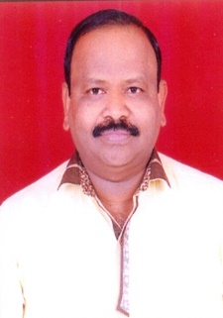

|  |  |  |
| --- | --- | --- |
| **1** | Name : | **Mr. Prafulla Manohar Dhavane** |
| **2** | Designation : | Librarian |
| **3** | Address : | 11, Kamal Matrushri Row House, Chetnanagar  Nashik,Dist.Nashik - 422009 |
| **4** | DateofBirth : | 01June,1968 |
| **5** | MobileNo. : | 8275318377 |
| **6** | EmailAddress : | prafulladhavane@gmail.com |
| **7** | AadharNumber : | 8016 5535 7998 |
| **8** | PANNumber : | AEIPD3599M |
|  |  |  |
| **9** | EducationalQualification : |  |

|  |  |  |  |
| --- | --- | --- | --- |
| **S.N.** | **Nameof Exam** | **University** | **PassingYear** |
| 1 | M.Lib. & I. Sci. | Dr. BabasahebAmbedkarMarathwada University, ChatrapatiSambhajinagar | 1997 |
| 2 | M. Phil. | Madurai kamraj University , Madurai | 2008 |

**10** Experience :

|  |  |  |
| --- | --- | --- |
| 1 | 24 years | 9 Months |

**11** Seminar/ConferenceAttendedandResearchPaperPresentedResourcePerson

|  |  |  |  |
| --- | --- | --- | --- |
| **Level** | **Attended** | **ResearchPaperPresented** | **ResourcePerson** |
| InternationalLevel | 10 | 10 | -- |
| NationalLevel | 6 | 6 | -- |
| StateLevel | 5 | 00 | -- |
| **Total** | **21** | **16** | **--** |

**12**TotalNo'sofResearchPapers :Published

|  |  |  |
| --- | --- | --- |
| ◾ | InJournalsbearingISSN | 16 |
| ◾ | In Conferences/SeminarsProceedingsbearingISBN | 22 |